Investment Banking FIX Lab — SQL with PostgreSQL
This applied lab combines SQL querying with realistic FIX (Financial Information eXchange) execution data. Load the schema and sample data, then solve 10 analysis scenarios by writing SQL. Optional smoke checks are provided in the seed file.

Candidate Instructions:
- Create a database in PostgreSQL,
- Run “ib_fix_lab_full.sql” to create the database schema.
- Write the SQL statements for each scenario.
- Create a sub-folder “2.SQL_and_PostgreSQL” as below:
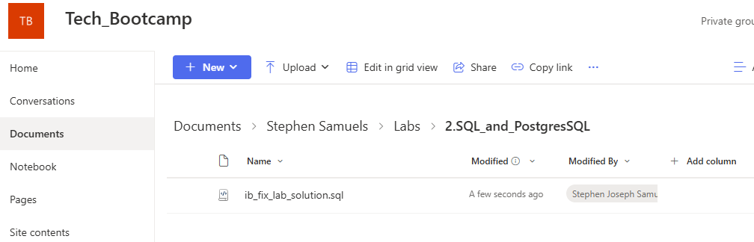
- Upload your SQL script to your folder in Sharepoint as above.

What’s in the Dataset
• Participants: Alpha AM, Beta Capital (clients); Gotham Securities, Metro Securities (brokers)
• Venues: NSE (XNSE), BSE (XBOM)
• Instruments: INFY, TCS, RELIANCE, HDFC, SBIN, AXISBANK (EQ in INR)
• Orders: mix of New/Partial/Fill/Cancel/Replace/Reject; timestamps on 2025‑10‑29
• Executions: fills/cancels with LastPx (31), LastQty (32), ExecType (150), OrdStatus (39); includes fees and liquidity flags
• Benchmarks: per‑instrument benchmark prices for slippage exercises on 2025‑10‑29
• Risk limits: per‑client daily notional limits

The 10 Scenarios (Write SQL)

1) Per‑symbol VWAP (weighted average price) on 2025‑10‑29
Use executions with exec_type_code IN ('1','2'). Compute VWAP = sum(last_px*last_qty)/sum(last_qty).
Output: symbol, vwap (2 decimals), sorted by symbol.
Hint:
- Use executions joined with orders and instruments.
- Filter exec_type_code IN ('1','2') and date = 2025-10-29.
- Compute SUM(last_px * last_qty) / SUM(last_qty) grouped by symbol.
- Use ROUND(..., 2) for formatting.

2) Order fill ratio & status
For each order, compute fill_ratio = cum_qty / order_qty (0–1), show status code and side. Filter: only Alpha AM.
Output: cl_ord_id, symbol, side, status_code, order_qty, cum_qty, fill_ratio (2 decimals).
Hint:
- Start from orders joined with instruments and participants.
- Compute cum_qty / order_qty as fill_ratio.
- Filter p.name = 'Alpha AM'.
- Use CASE for side (1=BUY, 2=SELL).

3) Client × Venue notional & top venue
Aggregate traded notional by venue per client using executions (fills/partials). Rank venues within each client.
Output: client, venue, notional, rank_in_client (1=top).
Hint:
- Aggregate SUM(last_px * last_qty) from executions grouped by client_id, venue_id.
- Join participants and venues for names.
- Use RANK() OVER (PARTITION BY client ORDER BY notional DESC) for ranking.

4) Slippage vs benchmark
Compute slippage vs benchmark_px for 2025-10-29: For Buys, slippage = (last_px - benchmark_px); for Sells, slippage = (benchmark_px - last_px).
Output: cl_ord_id, symbol, side, last_px, benchmark_px, slippage (2 decimals). Then avg slippage per client × symbol.
Hint:
- Join executions, orders, instrument_prices.
- Compute slippage:
  - For BUY: (last_px - benchmark_px)
  - For SELL: (benchmark_px - last_px)
- Use CASE for side logic.
- For averages: group by client_id, symbol.

5) Time‑to‑fill (TTF)
For fully filled orders (status_code='2'), compute seconds from order_ts to the last execution timestamp.
Output: cl_ord_id, symbol, ttf_seconds (desc). Bonus: 95th percentile TTF (percentile_cont).
Hint:
- For fully filled orders (status_code='2'), find MAX(exec_ts) per order.
- Subtract order_ts from that timestamp using EXTRACT(EPOCH FROM (...)).
- Bonus: percentile_cont(0.95) for 95th percentile.

6) Cancel/Replace chains
Link replacements via orig_cl_ord_id (e.g., A5 → A5R1). For each root order, count replaces and report latest leaves_qty.
Output: root_cl_ord_id, replace_count, latest_cl_ord_id, latest_status, leaves_qty.
Hint:
- Use a recursive CTE to follow orig_cl_ord_id.
- Count replacements and pick latest by order_ts.
- Use ROW_NUMBER() for latest order in chain.

7) Rejections dashboard
List rejected orders (status_code='8') with reason (from executions.reject_reason). Classify reason into Credit / Risk / Other by keyword.
Output: cl_ord_id, symbol, reason, class.
Hint:
- Filter orders.status_code='8'.
- Get reject_reason from executions where exec_type_code='8'.
- Classify using CASE WHEN reason ILIKE '%credit%' THEN 'Credit' ....

8) Limit vs execution “savings”
For Buy limit orders with fills, compute savings = (limit_price - vwap_exec) * cum_qty. Negative means worse than limit.
Output: cl_ord_id, symbol, limit_price, vwap_exec, cum_qty, savings_in_inr.
Hint:
- Compute VWAP per order: SUM(last_px * last_qty)/SUM(last_qty).
- Savings = (limit_price - vwap_exec) * cum_qty.
- Filter BUY LIMIT orders with cum_qty > 0.

9) Liquidity & fees
By client × liquidity_flag, compute total fees and notional; fee_bps = fees/notional*10_000.
Output: client, liquidity_flag, total_fees, notional, fee_bps (2 decimals).
Hint:
- Group by client_id, liquidity_flag.
- Compute SUM(fee_amt) and SUM(last_px * last_qty).
- Fee bps = (fees / notional) * 10_000.

10) Risk‑limit breach alert
Join risk_limits; flag clients whose day notional exceeds the limit on 2025‑10‑29.
Output: client, day_notional, limit, breach (Y/N). Bonus: top 3 orders by notional contributing to breach.
Hint:
- Aggregate daily notional per client.
- Compare with risk_limits.daily_notional_limit.
- Bonus: Use ROW_NUMBER() to rank top 3 orders by notional.

Notes & Hints
• Treat only ExecType 1/2 as traded volume (partials/fills).
• Use window functions (RANK/DENSE_RANK), CTEs and conditional aggregation as needed.
• Time zone in sample timestamps is Asia/Kolkata (+05:30).

FIX Quick‑Reference
• 35=8 is Execution Report — communicates order acks, fills, cancels, status. (OnixS / TT FIX Help)
• 150 (ExecType): reason for report (e.g., 0=New, 1=Partial fill, 2=Fill, 4=Cancelled, 5=Replaced, 8=Rejected). (OnixS/B2BITS)
• 39 (OrdStatus): current order state (e.g., 0=New, 1=Partially filled, 2=Filled, 4=Cancelled, 5=Replaced, 8=Rejected). (OnixS/InfoReach)
• 55 (Symbol) is the ticker; 54 (Side) 1=Buy, 2=Sell. (OnixS/InfoReach)
• 31 (LastPx) and 32 (LastQty) are price/quantity of the last fill. (OnixS/B2BITS)
• 11 (ClOrdID) is client order id; 37 (OrderID) broker/venue id; 17 (ExecID) unique execution id. (OnixS/InfoReach)

References
• Execution Report 35=8 — OnixS FIX 4.2: https://www.onixs.biz/fix-dictionary/4.2/msgtype_8_8.html
• Execution Report (8) — TT FIX: https://library.tradingtechnologies.com/tt-fix/order-routing/Msg_ExecutionReport_8.html
• ExecType (150) — OnixS FIX 4.2: https://www.onixs.biz/fix-dictionary/4.2/tagnum_150.html
• OrdStatus (39) — OnixS FIX 4.4: https://www.onixs.biz/fix-dictionary/4.4/tagnum_39.html
• OrdStatus (39) — InfoReach FIX 4.4: https://www.inforeachinc.com/fix-dictionary/fix_4_4_fields_ordstatus
• Symbol (55) — OnixS FIX 4.4: https://www.onixs.biz/fix-dictionary/4.4/tagnum_55.html
• Side (54) — OnixS FIX 4.2: https://www.onixs.biz/fix-dictionary/4.2/tagnum_54.html
• LastPx (31) — OnixS FIX 4.2: https://www.onixs.biz/fix-dictionary/4.2/tagnum_31.html
• LastQty (32) — B2BITS FIX 4.4: https://b2bits.com/fixopaedia/fixdic44/tag_32_LastQty_.html
• ClOrdID (11) — OnixS FIX 4.2: https://www.onixs.biz/fix-dictionary/4.2/tagnum_11.html
• ExecID (17) — OnixS FIX 4.2: https://www.onixs.biz/fix-dictionary/4.2/tagnum_17.html
• What is FIX — FIX Trading Community: https://www.fixtrading.org/what-is-fix/

======================================================================

